IET DEPARTMENT



Data Structure and Algorithm
Lab Manual
Lab 8: Queue Data Structure
Objectives:
- Queue
- Queue using Linked List Concept
- Queue using Array Concept
- Circular Queue

Introduction
A Queue is a linear structure which follows a particular order in which the operations are performed. The order is First In First Out (FIFO). A good example of a queue is any queue of consumers for a resource where the consumer that came first is served first. The difference between stacks and queues is in removing. In a stack we remove the item the most recently added; in a queue, we remove the item the least recently added.
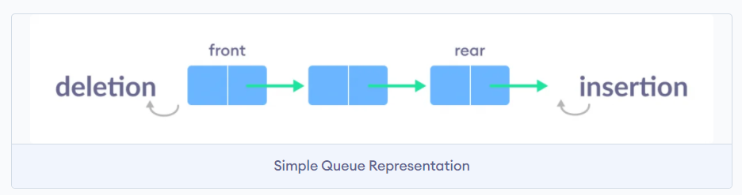
Concept Map
Queue (FIFO)
Queue is also an abstract data type or a linear data structure, just like stack data structure, in which the first element is inserted from one end called the REAR(also called tail), and the removal of existing element takes place from the other end called as FRONT(also called head).
Queue operations:
Queue operations may involve initializing or defining the queue, utilizing it, and then completely erasing it from the memory. Some of the operations are:
- enqueue() − add (store) an item to the queue.
- dequeue() − remove (access) an item from the queue.
- isfull() − Checks if the queue is full.
- isempty() − Checks if the queue is empty.
- enqueue() − add (store) an item to the queue.
Enqueue and Dequeue graphical representation
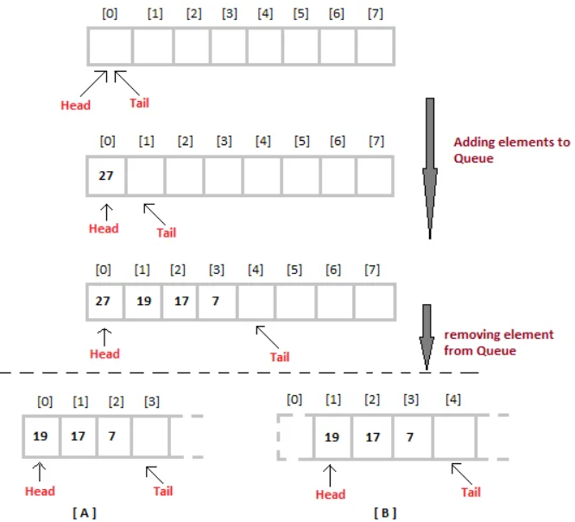
Queue Using Link List: Sample Program:
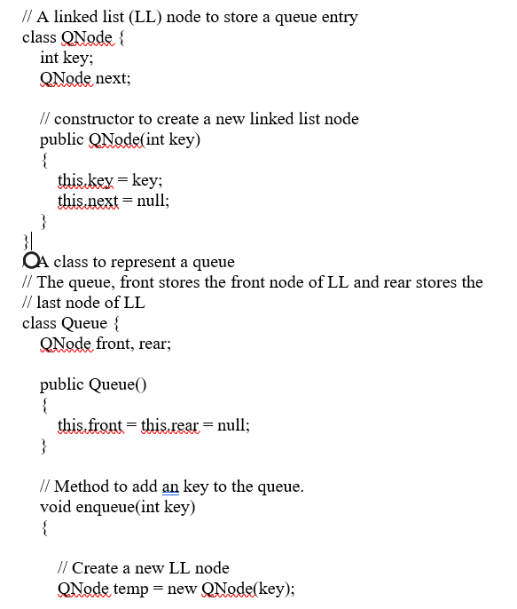
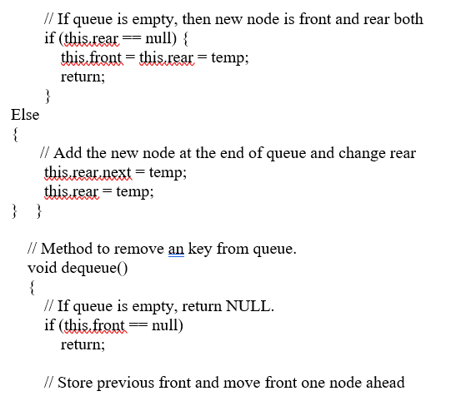
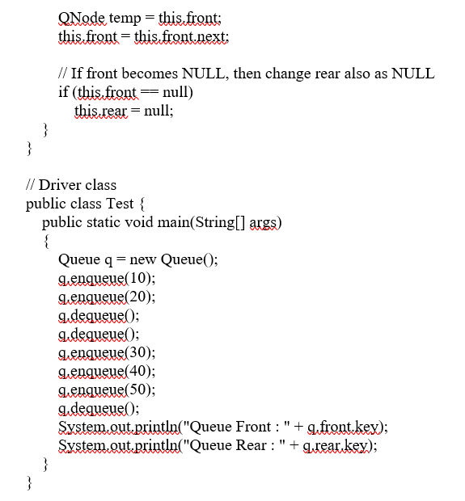
Circular Queue
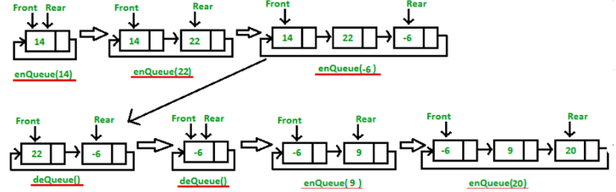
Sample Program

// Function to create Circular queue
static void enQueue( int value)
{
Node temp = new Node();
temp.data = value;
if (q.front == null)
q.front = temp;
else
q.rear.link = temp;
q.rear = temp;
q.rear.link = q.front;
}

// Function to delete element from Circular Queue
static int deQueue(Queue q)
{
if (q.front == null) {
System.out.printf("Queue is empty");
return Integer.MIN_VALUE;
}

// If this is the last node to be deleted
int value; // Value to be dequeued
if (q.front == q.rear) {
value = q.front.data;
q.front = null;
q.rear = null;
}
else // There are more than one nodes
{
Node temp = q.front;
value = temp.data;
q.front = q.front.link;
q.rear.link = q.front;
}

return value;
}

// Function displaying the elements of Circular Queue
static void displayQueue(Queue q)
{
Node temp = q.front;
System.out.printf("\nElements in Circular Queue are: ");
while (temp.link != q.front) {
System.out.printf("%d ", temp.data);
temp = temp.link;
}
System.out.printf("%d", temp.data);
}

Practice Tasks
Task 1:
There is a garage where the access road can accommodate any number of trucks at one time. The garage is built in such a way that only the first truck entered can be moved out. Each of the trucks is identified by a positive integer (a truck_id). Write a program to handle truck moves, allowing for the following commands:
- Enter_garage(truck_ id);
- Exit_garage(truck_id);
- Show_trucks();
If an attempt is made to get out a truck which is not the closest to the garage exit, show the error message “Truck is not near garage exit door”
Input | Output
Show_trucks();  Enter_garage(2);  Enter_garage(8);  Enter_garage(1);  Enter_garage(9);  Exit_garage(2);  Show_trucks();  Exit_garage(9) | Empty garage  2  8 2  1 8 2  9 1 8 2  9 1 8  “Truck is not near garage exit door”

Task 2: The Josephus Problem (circular link list)
There are n people standing in a circle waiting to be executed. After the first man is executed, k - 1 people are skipped and the k-th man is executed. Then again, k-1 people are skipped and the k-th man is executed. The elimination proceeds around the circle (which is becoming smaller and smaller as the executed people are removed), until only the last man remains, who is given freedom. The task is to choose the place in the initial circle so that you survive, given n and k.
N=5, K=2 (first node =1)
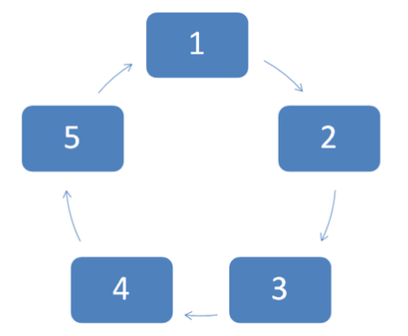

Evaluation criteria

The evaluation criteria for this lab will be based on the completion of the following tasks. Each task is assigned the marks percentage which will be evaluated by the instructor in the lab whether the student has finished the complete/partial task(s).

Further Reading
The slides and reading material can be accessed from the folder of the class instructor available at LMS.

Out comes
The outcomes of this lab were:
- Queue
- Queue using Linked List Concept
- Queue using Array Concept
- Circular Queue

